Create, Order, and Schedule Jenkins Jobs

Created 3 jobs:
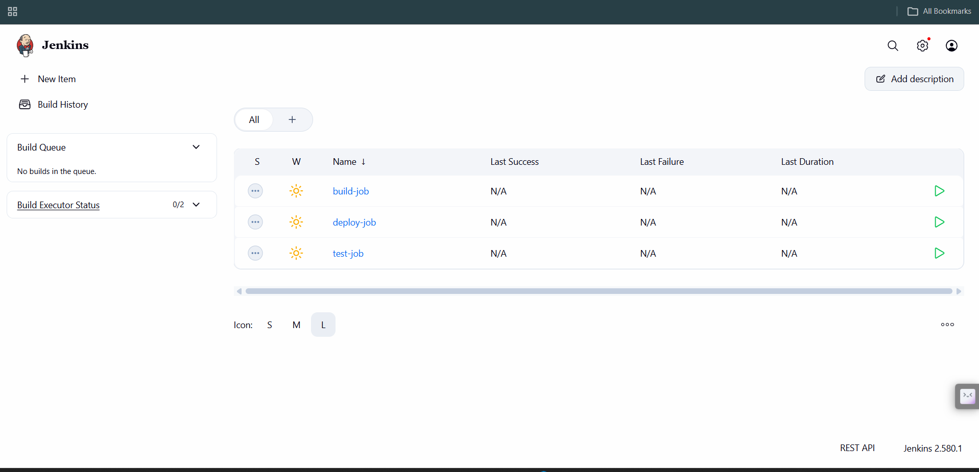

Job ordering:
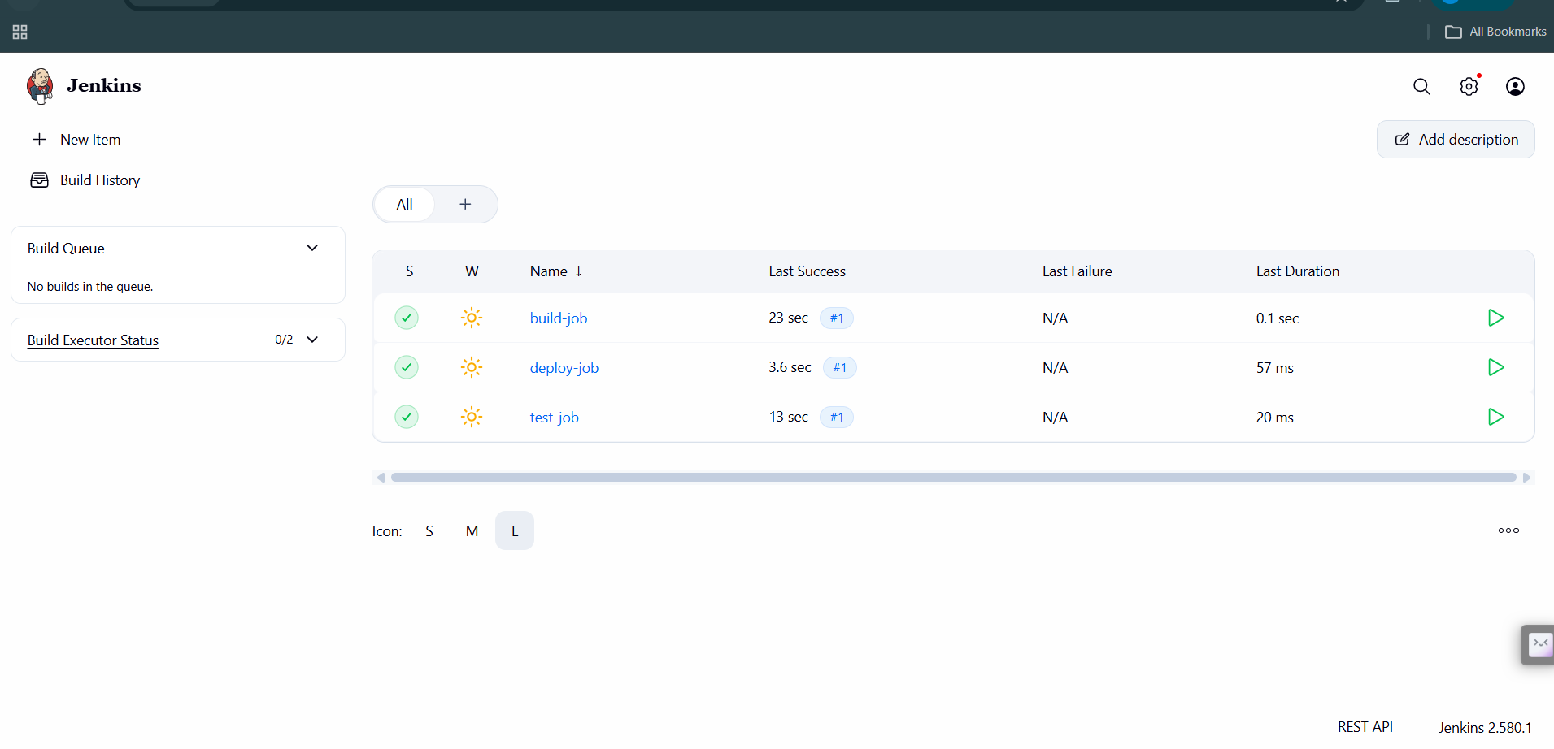

Job Scheduling: